SPIRITUAL & WELLNESS TOUR


Circuit: Delhi – Varanasi – Bodhgaya – Patna – Amritsar – Dharamshala – Shimla – Manali –
Chandigarh – Haridwar – Rishikesh – Delhi
ITINERARY PUBLISHED:
DAY 01: | ARRIVAL DELHI
Meeting and assistance upon arrival at Delhi International Airport and transfer to the hotel. Upon arrival, check in at hotel in Delhi.

Overnight stay at hotel in Delhi

DAY 02: | DELHI – VARANASI (6E 2571 – 10:30 / 11:45 Hrs)
Morning after breakfast drive to airport to board flight for Varanasi. Meeting and assistance upon arrival at Varanasi airport and transfer to hotel in Varanasi.

Varanasi, often revered as the spiritual capital of India, is one of the world’s oldest living cities—a timeless destination where faith, philosophy, culture, and tradition flow as seamlessly as the sacred Ganges that graces its shores. Nestled along the banks of the holy river in Uttar Pradesh, this ancient city is a profound confluence of devotion and heritage, drawing pilgrims, scholars, and travelers from across the globe. Steeped in mythology and history, Varanasi is believed to have been founded by Lord Shiva himself, making it one of the most sacred centers of Hindu belief. For millennia, seekers have journeyed here in pursuit of spiritual awakening, liberation (moksha), and divine blessings. The city’s iconic ghats—stone steps descending to the river—serve as the focal point of daily rituals, sacred ceremonies, and the eternal rhythm of life and death that defines its character.

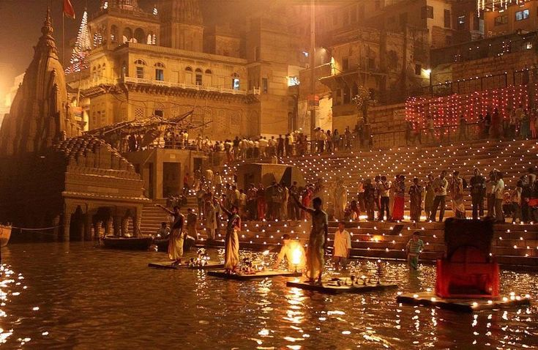
Evening wittness aarti ceremony on river Ganges. The Ganga Aarti in Varanasi is one of India’s most captivating and spiritually uplifting rituals, performed every evening on the sacred banks of the River Ganges. This grand ceremony is a devotional offering to Mother Ganga, revered in Hindu belief as a goddess who purifies the soul and washes away sins. The most prominent and widely attended Aarti takes place at Dashashwamedh Ghat, where a group of young priests dressed in traditional saffron and cream attire perform the ritual in perfect synchronization. As dusk settles over the river, the atmosphere transforms into a divine spectacle of rhythmic chants, resonating temple bells, conch shells, and the fragrance of incense. The ceremony begins with Vedic mantras and devotional hymns, followed by the priests holding large multi-tiered brass lamps blazing with fire. In graceful, circular movements, they offer light to the river while facing the sacred waters. The flames illuminate the twilight sky, reflecting beautifully on the flowing Ganges, creating an ethereal and unforgettable sight.

Overnight stay at hotel in Varanasi

DAY 03: | VARANASI
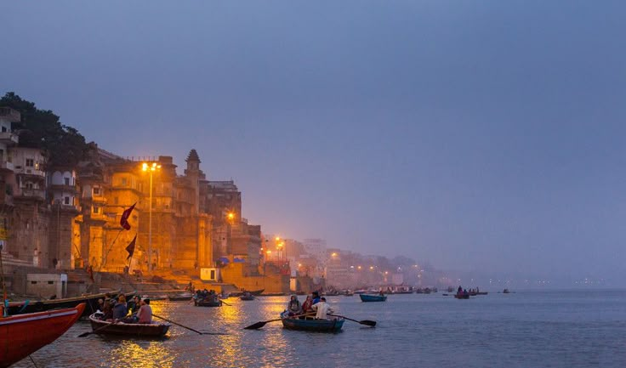
Begin your day with an early morning boat ride on the sacred River Ganges in Varanasi—an experience that captures the very soul of the city. As the first rays of the sun rise over the horizon, the riverfront comes alive with a timeless rhythm of devotion and daily life. From the boat, witness the long stretch of historic ghats where pilgrims gather to bathe in the holy waters, offer prayers, practice yoga, and perform age-old rituals. The sight of saffron-clad priests chanting Vedic hymns, devotees immersed in prayer, and locals beginning their day creates one of the most extraordinary and authentic experiences of India. You will also pass the sacred cremation ghats, where traditional last rites are performed—a powerful reminder of Varanasi’s deep spiritual connection with life, death, and liberation (moksha). Sunrise on the river, with its golden reflections dancing upon the gentle waters of the Ganges, is both serene and spiritually uplifting. The tranquil ambience, combined with the devotional fervor along the ghats, leaves a profound and lasting impression. Later, visit the revered Kashi Vishwanath Temple, also known as the Golden Temple due to its magnificent gold-plated spires. Dedicated to Lord Shiva and one of the twelve sacred Jyotirlingas, the temple stands as the spiritual nucleus of Varanasi. Please note that entry into the inner sanctum is permitted only to Hindus; however, the temple’s significance and architectural grandeur can be appreciated from the surrounding area.
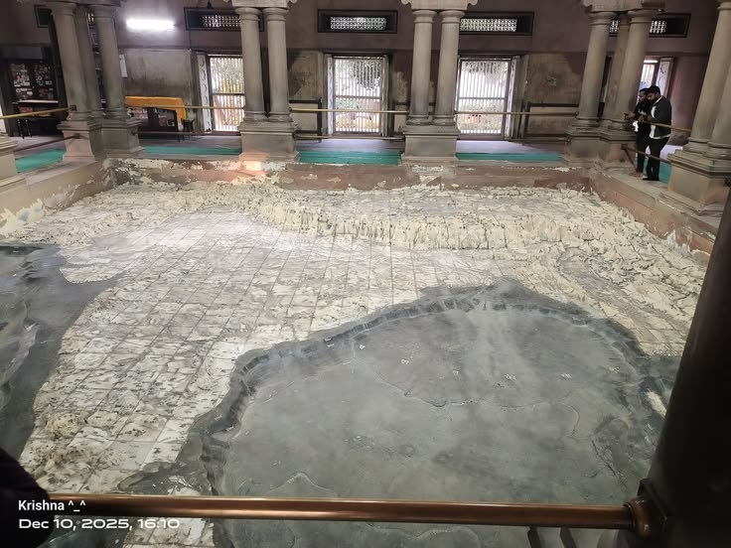
After boat ride return back to hotel for breakfast and relaxation. Later in the morning Embark on a half-day sightseeing tour of Varanasi, exploring its rich blend of spirituality, history, and architectural heritage. Begin with a visit to the unique Bharat Mata Temple, renowned for its remarkable marble relief map of undivided India carved in stone. Unlike traditional temples, this shrine is dedicated not to a deity, but to Mother India, symbolizing national unity and pride. Continue to the revered Durga Temple, popularly known as the Monkey Temple due to the presence of numerous monkeys in the vicinity. Dedicated to Goddess Durga, this vibrant red temple is an important center of devotion and reflects classic North Indian temple architecture. Next, visit the serene Tulsi Manas Temple, constructed entirely of white marble. The temple walls are beautifully engraved with verses and scenes from the Ramcharitmanas, the Hindi rendition of the epic Ramayana, composed by the saint-poet Tulsidas. Its tranquil ambiance and intricate inscriptions make it both spiritually and culturally significant. Proceed to the imposing New Vishwanath Temple, located within the campus of Banaras Hindu University. One of the tallest temples in India, this modern shrine is dedicated to Lord Shiva and stands as a symbol of devotion and academic excellence. (Please note that non-Hindus are not permitted inside the sanctum.) While at the university, take a drive through the expansive campus—one of Asia’s largest residential universities—and visit its museum, which houses an impressive collection of paintings, sculptures, and archaeological artifacts. Conclude your tour with a visit to the mosque built by the Mughal Emperor Aurangzeb, located near the riverfront. This historical structure reflects the layered cultural and architectural influences that have shaped Varanasi over centuries.
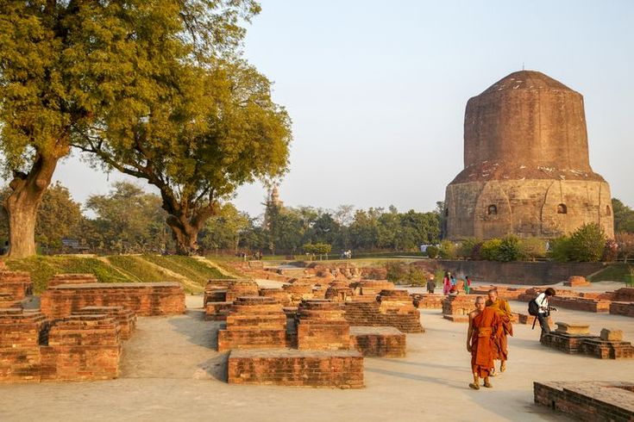
Afternoon proceed for the sacred site of Sarnath, one of the most revered Buddhist pilgrimage destinations in the world. It was here that Lord Buddha delivered his first sermon after attaining enlightenment, setting in motion the Wheel of Dharma. The tour is dominated by the magnificent Dhamek Stupa, a massive cylindrical structure that marks the exact spot where Buddha is believed to have preached the Dhammacakkappavattana Sutta to his first five disciples. Rising prominently amidst manicured lawns, the stupa stands as a powerful symbol of peace and spiritual awakening. Explore the extensive ruins of ancient monasteries that once formed part of a flourishing Buddhist learning center. These archaeological remains offer insight into the grandeur of Sarnath during the Mauryan and Gupta periods, when it was a major hub of scholarship and monastic life. You will also see the remnants of the legendary Ashoka Pillar, originally erected by Emperor Ashoka in the 3rd century BCE. Once soaring over 20 meters high, the pillar symbolized the emperor’s devotion to Buddhism and his commitment to spreading its teachings. Conclude your visit at the Sarnath Archaeological Museum, which houses an exceptional collection of artifacts excavated from the site. Among its most celebrated treasures is the Lion Capital of Ashoka, now adopted as the National Emblem of India—a masterpiece of ancient Indian sculpture and craftsmanship.

Overnight stay at hotel in Varanasi.

DAY 04: | VARANASI – BODHGAYA (255 Kms , 05 Hrs drive)
Morning after breakfast drive to Bodhgaya. Upon arrival check in at hotel in Bodhgaya. The serene village of Bodh Gaya, situated on the tranquil banks of the Niranjana River and approximately 16 km from Gaya, stands as one of the most sacred Buddhist pilgrimage centres in the world. It was here that Prince Siddhartha attained Supreme Enlightenment and became the Buddha while meditating beneath the revered Bodhi Tree. At the heart of Bodhgaya lies the magnificent Mahabodhi Temple, a UNESCO World Heritage Site that marks the exact spot of enlightenment. Within the temple complex stands the sacred Bodhi Tree, whose present sapling is believed to be a direct descendant of the original tree under which enlightenment was attained. Pilgrims from across the globe gather here for meditation and prayer, enveloping the surroundings in an atmosphere of deep spiritual reverence and peace.
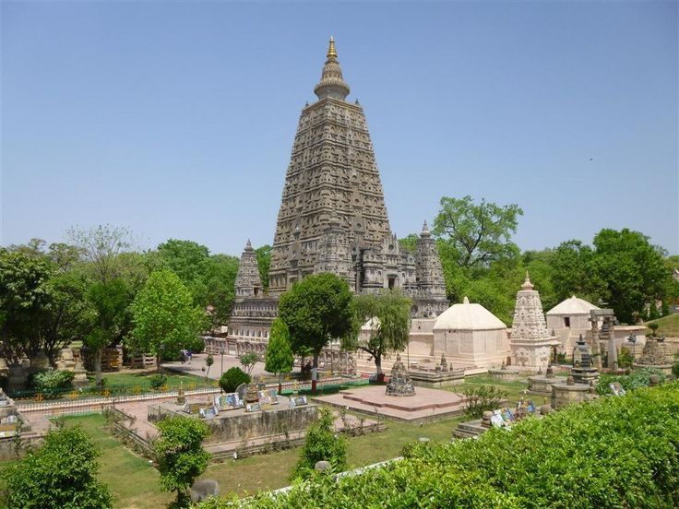
Afternoon proceed for sightseeing tour of Bodhgaya. In the sacred town of Bodh Gaya, one of the most revered Buddhist pilgrimage destinations in the world, experience the profound serenity of the place where Prince Siddhartha attained enlightenment and became the Buddha. Begin your visit at the magnificent Mahabodhi Temple, a UNESCO World Heritage Site distinguished by its soaring 54-meter pyramidal spire. The temple enshrines a large gilded image of the Enlightened Buddha in a serene meditative posture, marking the sacred spot associated with his awakening. The spiritual ambiance of the complex, enhanced by chanting monks and prayer flags, creates a deeply contemplative atmosphere. Adjacent to the temple stands the revered Bodhi Tree, believed to be a direct descendant of the original tree under which Buddha attained enlightenment. At its base lies the Vajrasila, a sandstone slab marking the precise location where he sat in meditation—a site of immense spiritual significance for devotees from around the globe. Visit the local archaeological museum, which houses an impressive collection of sculptures, relics, and artifacts excavated from the region, offering insight into the rich historical legacy of Buddhism. Continue to explore the numerous international monasteries built by Buddhist communities from countries such as Thailand, Japan, Bhutan, and Sri Lanka. Each monastery reflects distinctive architectural styles and artistic traditions, symbolizing the universal reach of Buddhist philosophy.

Overnight stay at hotel in Bodhgaya.

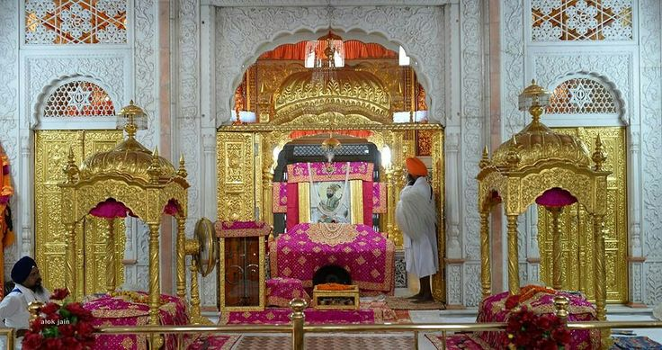
DAY 05: | BODHGAYA – PATNA (116 Kms, 02 Hrs drive)
Morning after breakfast drive to Patna. Upon arrival check in at hotel in Patna. Afternoon explore the historic city of Patna, one of the oldest continuously inhabited cities in the world and a place rich in religious, colonial, and cultural heritage. Begin your tour with a visit to the revered Takht Sri Patna Sahib (Harmandir Sahib), a magnificent 19th-century Sikh shrine built in gleaming white marble by Maharaja Ranjit Singh. The temple marks the birthplace of Guru Gobind Singh, the tenth and last Sikh Guru. One of the five Takhts (temporal seats of authority) of Sikhism, it is an important pilgrimage site and a symbol of devotion, courage, and spiritual strength. Continue to the iconic Golghar, an impressive beehive-shaped granary constructed by the British in 1786 to store grain following a devastating famine. This massive structure, with its unique spiral stairway and panoramic views from the top, stands as a reminder of Patna’s colonial past. Next, visit the renowned Patna Museum, which houses a rich collection of archaeological artifacts, sculptures from the Mauryan and Gupta periods, original Chinese and Tibetan thangka paintings, and other invaluable relics reflecting Bihar’s glorious heritage. Conclude your exploration at the distinguished Khuda Bakhsh Oriental Public Library, an intellectual treasure trove known for its rare Persian and Arabic manuscripts, Mughal miniature paintings, and centuries-old literary works. This esteemed institution is a testament to Patna’s longstanding tradition of scholarship and cultural exchange.

Overnight stay at hotel in Patna
DAY 06: | PATNA – AMRITSAR (6E 5009 – 08:30 Hrs / 10:15 Hrs &
(6E 5064 – 12:30 Hrs / 13:40 Hrs – via Delhi flight)
Morning after breakfast drive to airport to board flight for Amritsar. Meeting and assistance Upon arrival at Amritsar airport and transfer to hotel in Amritsar.

Founded in 1577 by Guru Ram Das, the fourth Guru of the Sikhs, Amritsar derives its name from the sacred Amrit Sarovar—the “Pool of the Nectar of Immortality.” Revered as the spiritual heart of Sikhism, Amritsar holds profound religious significance and continues to draw pilgrims and visitors from across the world. Today, it is the second-largest city in the state of Punjab and was historically an important junction of trade routes connecting Central Asia and the Indian subcontinent. Over the centuries, the city has evolved into a vibrant cultural and commercial hub while retaining its deep-rooted spiritual identity. The principal attraction of Amritsar is the magnificent Golden Temple, also known as Sri Harmandir Sahib—the holiest shrine of Sikhism. Set amidst the sacred tank from which the city takes its name, the temple’s gilded façade reflects beautifully in the surrounding waters, creating an atmosphere of serenity and devotion. The shrine is open to people of all faiths and symbolizes equality, humility, and universal brotherhood. Amritsar is not merely a city; it is a living testament to Sikh heritage, faith, and resilience—where spirituality, history, and vibrant Punjabi culture come together in a truly inspiring way.

Rest of the day free for relaxation.

Overnight stay at hotel in Amritsar

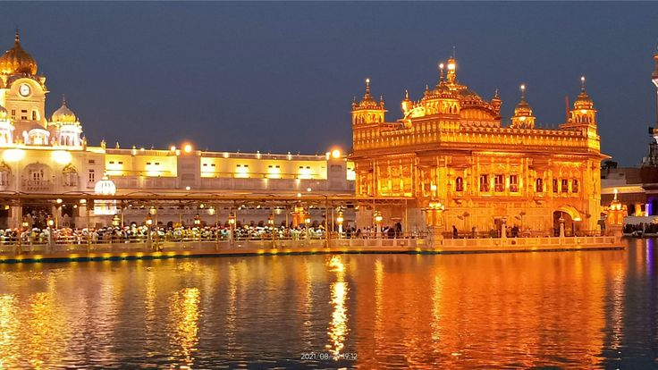
DAY 07: | AMRITSAR
Enjoy a half-day tour of Amritsar, exploring its profound spiritual heritage and historic landmarks. Begin with a visit to the magnificent Golden Temple, the spiritual nerve-centre of the Sikh faith. Also known as Harmandir Sahib, this sacred shrine is an architectural masterpiece of white marble and copper gilt, crowned with a dome richly covered in gold leaf. At its heart rests the revered Guru Granth Sahib, the holy scripture of Sikhism, recited continuously in an atmosphere of deep devotion. The temple complex welcomes people of all faiths and stands as a symbol of equality and universal brotherhood. Within the complex, witness the remarkable community kitchen, or langar, where thousands of volunteers prepare and serve free meals to nearly 30,000 visitors daily—an extraordinary example of humility, service, and shared humanity. Later, visit the historic Jallianwala Bagh, a solemn memorial commemorating the tragic massacre of 1919, when hundreds of unarmed Indians were killed or wounded by British troops. The preserved bullet marks and memorial structures serve as a poignant reminder of India’s struggle for independence. Conclude your tour at the serene Ram Bagh, also known as Company Garden, a beautifully landscaped green space that offers a peaceful retreat amidst the city’s vibrant energy.

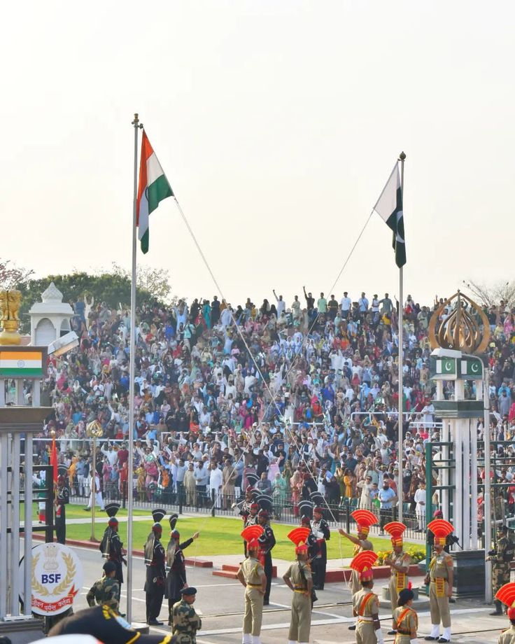
Afternoon visit Wagah Border: Located approximately 30 kilometers from Amritsar, the Wagah Border marks the international boundary between India and Pakistan and is one of the most visited border points in South Asia. It lies on the historic Grand Trunk Road connecting Amritsar with Lahore. The Wagah Border is internationally renowned for its daily Beating Retreat Ceremony, a highly spirited and patriotic military ritual conducted jointly by India’s Border Security Force (BSF) and Pakistan Rangers. Held every evening before sunset, the ceremony features synchronized marching, high-kicking drills, ceremonial flag lowering, and enthusiastic participation from the crowd. As spectators gather in large numbers on both sides of the border, the atmosphere becomes electrifying with patriotic slogans, music, and cheering. The ceremony concludes with the simultaneous lowering of the national flags of both countries and the closing of the border gates for the night. More than just a military display, the Wagah Border ceremony symbolizes discipline, national pride, and the complex yet shared history between the two nations. A visit here offers a unique and memorable experience, adding a powerful patriotic dimension to your stay in Amritsar.

Overnight stay at hotel in Amritsar

DAY 08: | AMRITSAR – DHARAMSHALA (201 Kms, 04 Hrs drive)
Morning after breakfast drive to Dharamshala. Upon arrival check in at hotel in Dharamshala. Nestled in the serene Kangra Valley against the dramatic backdrop of the Dhauladhar mountain range, Dharamshala is one of Himachal Pradesh’s most picturesque hill destinations. Renowned for its natural beauty, spiritual ambiance, and Tibetan cultural influence, the town offers a refreshing blend of tranquility and vibrant heritage. Divided into Lower Dharamshala and Upper Dharamshala (McLeod Ganj), the area gained international prominence as the residence of Dalai Lama and the seat of the Tibetan Government-in-Exile. This has transformed Dharamshala into a significant center of Tibetan Buddhism, attracting spiritual seekers and travelers from across the globe.

Overnight stay at hotel in Dharamshala

DAY 09: | DHARAMSHALA
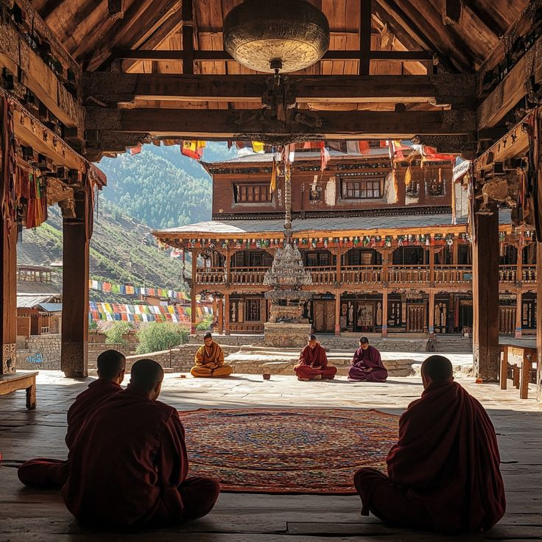
Following the Chinese invasion of Tibet in 1959, His Holiness Dalai Lama, the spiritual head of Tibetan Buddhism, settled in Dharamshala, transforming it into a prominent center of Tibetan culture and spirituality. His residence is located within the Tsuglagkhang Complex in McLeod Ganj, and on special occasions, visitors may have the opportunity to attend public teachings or, if fortunate, be granted an audience. McLeod Ganj, often referred to as “Little Lhasa,” forms the vibrant Tibetan quarter of the town and attracts the majority of visitors. The area is rich in monasteries, temples, meditation centers, and traditional Tibetan handicraft shops. Among the key spiritual landmarks is Namgyal Monastery, the personal monastery of the Dalai Lama and an important center for Buddhist learning and rituals. Nearby stands the serene Kalachakra Temple, known for its intricate murals and sacred Buddhist teachings. A short drive away, visit the renowned Norbulingka Institute, dedicated to the preservation of Tibetan art, culture, and literature. The institute’s beautifully landscaped gardens and traditional architecture offer a tranquil cultural experience. Within walking distance from McLeod Ganj lies the scenic Bhagsunag Temple and the adjacent Bhagsunag Waterfall. Surrounded by lush greenery and hills, this sacred temple and cascading waterfall provide a refreshing natural retreat.

Overnight stay at hotel in Dharamshala

DAY 10: | DHARAMSHALA – SHIMLA (232 Kms, 06 Hrs drive)
Morning after breakfast drive to Shimla. Upon arrival check in at Shimla.

Fondly referred to by the British as the “Queen of Hill Stations,” Shimla is one of India’s most charming mountain retreats. Nestled in the northwestern Himalayas at an elevation of approximately 7,238 feet, it once served as the summer capital of British India and today stands as the capital of Himachal Pradesh.
The name Shimla is derived from “Shyamala,” another name for Goddess Kali, whose temple once stood amidst the dense forests covering Jakhu Hill in the early 19th century. Over time, the British adapted the name to “Shimla,” and the town gradually evolved into a favored colonial escape from the plains’ summer heat. Spread across nearly 18 square kilometers, Shimla is enveloped by picturesque forests of pine, deodar, oak, and rhododendron. Its colonial-era architecture, scenic promenades, and cool mountain air lend the city a timeless appeal. Landmarks such as the Viceregal Lodge, Christ Church, and the bustling Mall Road reflect its rich historical legacy.

Overnight stay at hotel in Shimla

DAY 11: | SHIMLA
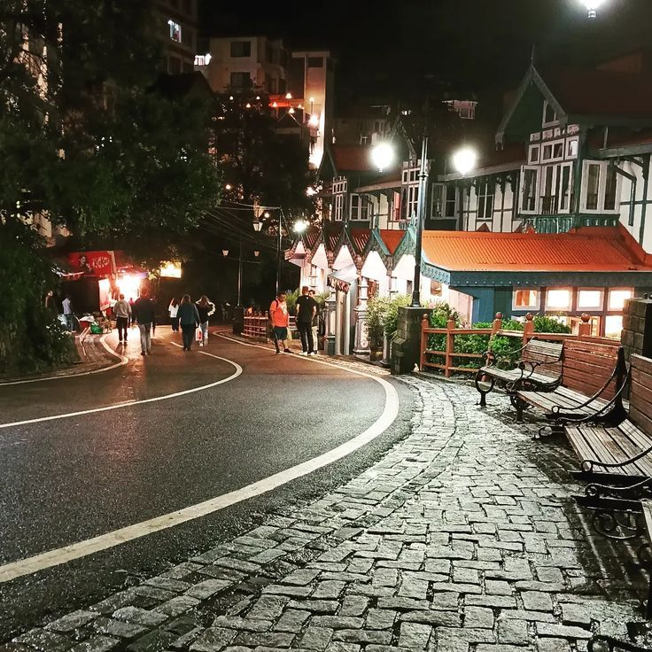
Morning after breakfast proceed for sightseeing tour of Shimla. Begin with a leisurely stroll along The Mall Road, the vibrant heart of Shimla, lined with colonial-era buildings, cafés, boutiques, and souvenir shops. Nearby stands the iconic Christ Church, one of the oldest churches in North India, known for its neo-Gothic architecture and beautiful stained-glass windows. Visit the historic Viceregal Lodge (also known as Rashtrapati Niwas), a grand colonial structure that once served as the residence of the British Viceroy. Surrounded by manicured gardens, the building reflects remarkable Scottish baronial architecture and played a key role during India’s independence era. Proceed to Jakhu Temple, situated atop Jakhu Hill—the highest point in Shimla. Dedicated to Lord Hanuman, the temple offers breathtaking panoramic views of the surrounding mountains and valleys. Nature lovers can explore The Ridge, an open space offering spectacular sunset views, or take a scenic drive to Kufri, a nearby hill spot known for its natural beauty and adventure activities.

Overnight stay at hotel in Shimla

DAY 12: | SHIMLA – CHANDIGARH (109 Kms, 02 Hrs drive)
Morning after breakfast drive to Chandigarh. Upon arrival check in at hotel in Chandigarh.
Chandigarh, the joint capital of Punjab and Haryana, stands apart as one of India’s most meticulously planned and modern cities. Designed by the renowned French architect Le Corbusier, the city represents a bold experiment in urban planning and contemporary architecture in post-independence India. Unlike the organically evolved cities of the country, Chandigarh was carefully structured into well-defined sectors, each functioning as a self-sufficient neighborhood. Broad tree-lined boulevards, organized layouts, landscaped gardens, and modernist government buildings give the city a distinctive character and an overall air of order and prosperity. The architectural landmarks of the Capitol Complex, geometric forms, and open spaces reflect Le Corbusier’s vision of a progressive India. Combined with its clean environment and abundant green spaces, Chandigarh offers a refreshing contrast to traditional Indian cityscapes—making it a symbol of modern urban design and civic planning in the country.

Rest of the day free for relaxation / explore surroundings

Overnight stay at hotel in Chandigarh

DAY 13: | CHANDIGARH
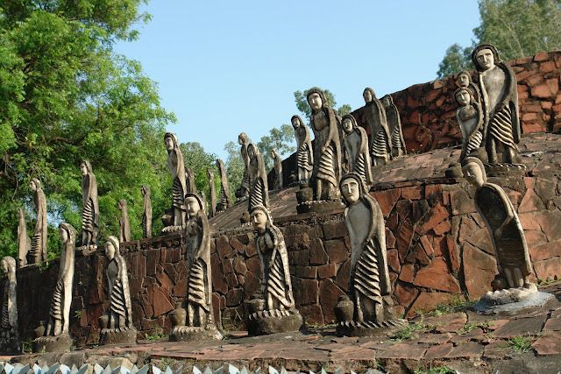
Morning after breakfast enjoy a half-day tour of Chandigarh, a city celebrated for its modern architecture and thoughtfully planned layout. Begin with a visit to the iconic Capitol Complex, which houses the imposing Secretariat Building, the striking Punjab and Haryana Legislative Assembly, and the multi-pillared Punjab and Haryana High Court. Designed by the visionary architect Le Corbusier, these monumental structures exemplify bold modernist design and symbolize India’s progressive spirit after independence. Continue to the State Library and Panjab University campus, both reflecting the city’s emphasis on education and cultural development. Later, unwind amidst nature at the renowned Zakir Hussain Rose Garden, home to more than 1,500 varieties of roses and one of Asia’s largest rose gardens. Stroll through its beautifully landscaped lawns and vibrant floral displays. Also visit the Botanical Garden, a tranquil retreat showcasing diverse plant species, before concluding your tour at the picturesque Sukhna Lake. This serene man-made lake, set against the backdrop of the Shivalik Hills, offers a peaceful environment ideal for leisurely walks and scenic views.

Overnight stay at hotel in Chandigarh

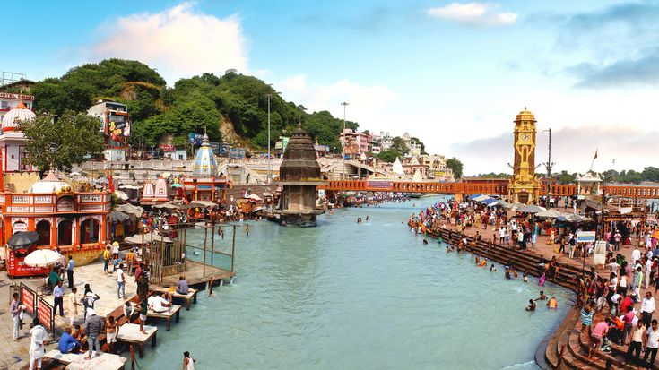
DAY 15: | CHANDIGARH – HARIDWAR (226 Kms, 04 Hrs drive)
Morning after breakfast drive to Haridwar. Upon arrival check in at hotel in Haridwar. Literally meaning “Gateway to Lord Vishnu,” Haridwar is one of India’s most sacred pilgrimage destinations. Nestled at the base of the Shivalik Hills, it is a town of temples, ghats, and ashrams, where spirituality permeates every corner. Its unique location—where the River Ganges descends from the Himalayas and begins its journey across the northern plains—imbues the city with immense religious significance. Haridwar is one of the four sites that host the grand Kumbh Mela, held every 12 years. During this extraordinary gathering, millions of pilgrims from across India and the world assemble to take a sacred dip in the holy river, believing it cleanses sins and grants spiritual merit. Steeped in mythology, Haridwar is also associated with various episodes from the ancient Indian epic Mahabharata, adding to its timeless aura. The most revered ghat in the city is Har Ki Pauri, where a sacred footprint of Lord Vishnu is believed to be imprinted in stone. Every evening, the ghat comes alive with the mesmerizing Ganga Aarti, as priests chant hymns and lamps are floated upon the river—an unforgettable spectacle of devotion and faith.

Overnight stay at hotel in Haridwar

DAY 14: | HARIDWAR – RISHIKESH – HARIDWAR (26 Kms, 41 Mnts One Way Drive)
Morning after proceed for same day excursion to Rishikesh. Rishikesh, often referred to as the “Gateway to the Himalayas,” is beautifully situated in the Tehri-Garhwal region of Uttarakhand. Blessed with abundant natural splendor, the town marks the point where the sacred River Ganga descends from the mountains and flows through the Himalayan foothills—creating a breathtaking and awe-inspiring spectacle. Located at an elevation of approximately 1,360 feet above sea level, Rishikesh is renowned as a spiritual haven. For centuries, yogis, sages, and seekers have chosen this serene landscape for meditation, penance, and the pursuit of enlightenment. Today, it is internationally recognized as the “Yoga Capital of the World,” attracting spiritual aspirants from across the globe. According to legend, Rishikesh is the site where Lord Vishnu vanquished the demon Madhu, adding mythological significance to its sacred identity. Numerous temples and ashrams line the banks of the Ganga, creating an atmosphere of devotion and tranquility. Iconic landmarks such as Lakshman Jhula and Ram Jhula offer panoramic views of the river and surrounding hills, enhancing the town’s charm. With its harmonious blend of spirituality, adventure, and natural beauty, Rishikesh stands as a serene retreat where the sacred river, Himalayan landscapes, and ancient traditions come together in perfect balance.

Overnight stay at hotel in Haridwar

DAY 15: | HARIDWAR – DELHI (22458: VANDE BHARAT EXPRESS – 08:09 Hrs / 11:45 Hrs)
Morning drop at Haridwar railway station to board train for Delhi. Meeting and assistance upon arrival at New Delhi station and transfer to hotel. Upon arrival check in at hotel in Delhi.

Perhaps no other capital city in the world is as deeply steeped in history and legend as Delhi, the heart of India. For centuries, it stood as a powerful magnet for invaders and emperors—drawing Mongols, Turks, Persians, Afghans, Mughals, and eventually the British. Each dynasty left behind an indelible imprint, contributing to the city’s glorious yet turbulent past. Such was the fascination with Delhi that despite being abandoned and rebuilt multiple times, its rulers continually returned, reconstructing it at least seven times over the centuries. From ancient fortified cities to grand imperial capitals, Delhi evolved as a symbol of authority, ambition, and resilience. Today, the twin cities of Old and New Delhi present a captivating contrast. Old Delhi echoes with the charm of narrow lanes, bustling bazaars, and Mughal-era monuments, while New Delhi reflects colonial grandeur and modern governance with its wide boulevards and stately buildings. Together, they form the cultural and political nucleus of the world’s largest democracy.

Overnight stay at hotel in Delhi
DAY 16: | DELHI
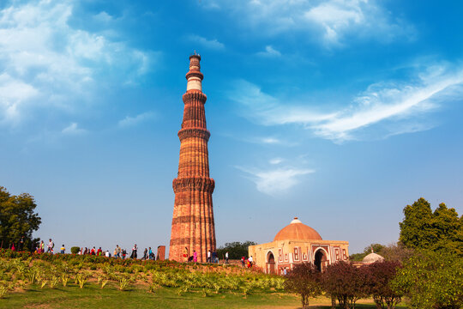
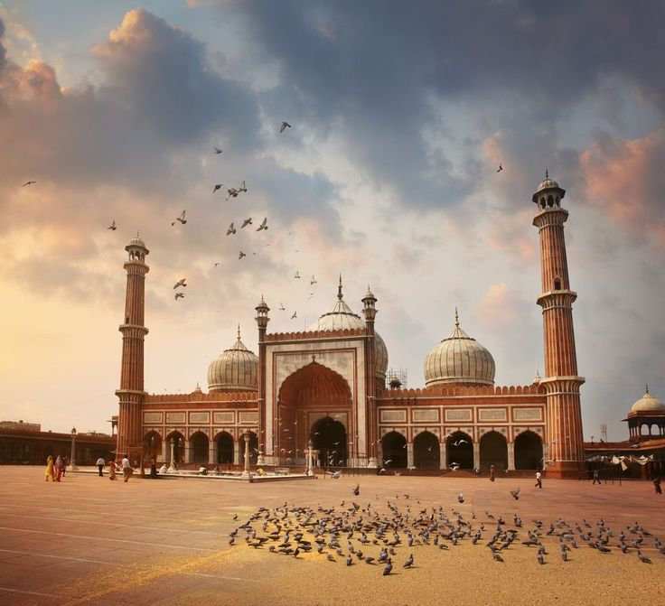
Morning a fter breakfast proceed for sightseeing tour of New & Old Delhi Sightseeing – A Journey Through Time : Explore the grandeur of New Delhi, a city designed in classic British colonial style, characterized by wide tree-lined avenues, expansive lawns, and elegant colonial bungalows. Begin your tour with a visit to the beautiful Laxminarayan Temple (Birla Temple), a modern Hindu shrine dedicated to Lord Vishnu and Goddess Lakshmi, known for its impressive architecture and serene ambiance. Continue to the iconic India Gate, the 42-meter-high war memorial arch commemorating Indian soldiers who lost their lives in World War I. Drive past the circular Parliament House, the imposing Secretariat Building, and the magnificent Rashtrapati Bhavan (formerly the Viceroy’s House), now the official residence of the President of India. Visit the towering Qutub Minar, a UNESCO World Heritage Site. Conceived as a grand tower of victory, it stands as one of the finest examples of Indo-Islamic Afghan architecture and inspired the design of many minarets across the subcontinent. Proceed to Old Delhi, where the atmosphere changes dramatically. Visit the magnificent 17th-century Jama Masjid, one of the largest mosques in India, built by Emperor Shah Jahan. Experience the vibrant energy of Chandni Chowk, the bustling market heart of Old Delhi, known for its narrow lanes, traditional shops, and lively bazaars. Drive past the majestic Red Fort for a photo stop—this UNESCO-listed monument once served as the main residence of the Mughal emperors. Conclude your tour at Raj Ghat, the serene memorial marking the cremation site of Mahatma Gandhi. Set amidst peaceful gardens, it stands as a tribute to the Father of the Nation. This comprehensive tour of New and Old Delhi offers a captivating blend of colonial elegance, Mughal grandeur, spiritual landmarks, and modern governance—revealing the many layers of India’s historic capital

Overnight stay at hotel in Delhi

DAY 17: | DEPART DELHI
On time transfer to airport to board flight for onward destination.

TOUR COST:
CATEGORY | COST PER PERSON
Cost for 02 paying pax | USD 2531 per person
Cost for 04 paying pax | USD 1951 per person
Cost for 06 paying pax | USD 1643 per person
Cost for 08 paying pax | USD 1515 per person
Cost for 10 paying pax | USD 1419 per person
Single Room Supplement | USD 773 per single room

CiTY | HOTEL | NIGHT
Delhi | Pride Aerocity or simiar | 01
Varanasi | New Broadway hotel or similar | 02
Bodhgaya | Anand International or similar | 02
Patna | Chanakya Hotel or similar | 01
Amritsar | Amritara Sadka or similar | 02
Dharamshala | Amritara Surya Resort or similar | 02
Shimla | Snow Valley Resort or similar | 02
Chandigarh | Velvet Clarks Exotica or simiar | 02
Haridwar | Fern Residency or similar | 02
Delhi | Park Inn By Radission I.P Extension or similar | 02
Total number of nights |  | 18 Nights

Air:
Sector | Fligt number | Departure | arrival
Delh / varanasi | 6E 2751 | 0830 Hrs | 1030 Hrs
Patna / Amritsar | 6E 5009  6E 5064 | 0830 Hrs  1230 Hrs | 1015 Hrs  1340 Hrs

Train
Sector | Train name & no | Departure | Arrival | Class
Haridwar / Delhi | 22458 Vande Bharat Express | 0800 hrs | 1145 hrs | A/C Cjair car

Our prices include:

Price per person in a Double room.

Bed and breakfast basis as per program

All arrival/departure transfer, sightseeing tour excursions by Air-conditioned vehicle.

Entrance fees to Monuments

Services of English speaking local guide as per program

Boat ride on river ganges

Train tickets by Airconditioned Chair Car by Vande Bharat Express for Travel Haridwar to Delhi

03 night in Delhi with bed and breakfast.

02 night in Varanasi with bed and breakfast

02 nights in Dharamshala with bed and breakfast basis.

02 nights in Shimla with bed and breakfast.

02 night in Chandigarh with bed & breakfast.

02 night in Haridwar with bed and breakfast basis

Government tax.

Our prices do not include:

Entry visa. Visas can be obtained online at: www.indianvisaonline.gov.in

Tips for guides (at the client's discretion).

Travel and cancellation insurance (optional).

Beverages.

Any services not mentioned as included, including personal extras such as telephone calls, laundry

service, etc.

